Tommy Aguilu

8/26/2019

Foundations of Programing

Assignment 7

Knowledge document

Introduction – The goal of this program is to take a CSV input and parse while also gracefully handling potential errors. Once it is parsed the output is saved as a pickle file so that it can be used in other functions that require pickle input.

Code Snippet

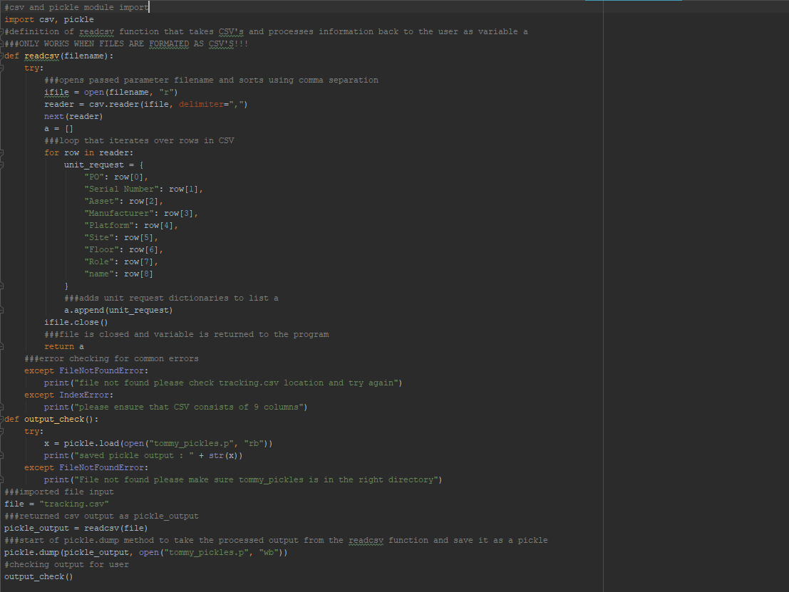

Section 1 – module loading

In this section we import the csv and pickle modules so that we can process pickles and csv’s correctly in later sections of the program.



Section 2 – CSV import

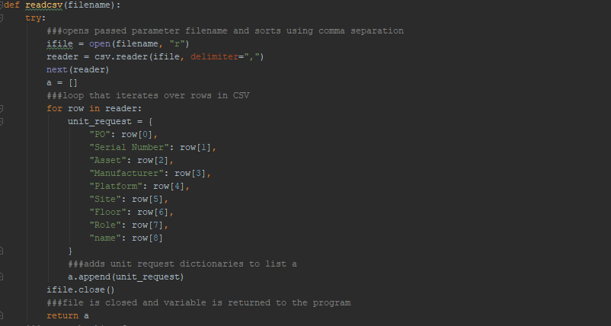

In this section we create/encapsulate the function that will import and process our CSV file. For each row in the imported CSV there are key value pairs created between the various columns by way of slicing the row positions.

https://realpython.com/python-csv/

Section 3 – Error handling

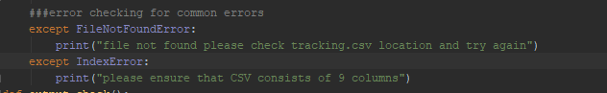

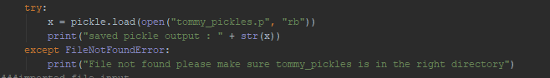

In these sections we include error handling for the common error types associated with this function, specifically ones related unexpected values or null values being imported.

https://docs.python.org/3/tutorial/errors.html

Section 4 - Saving

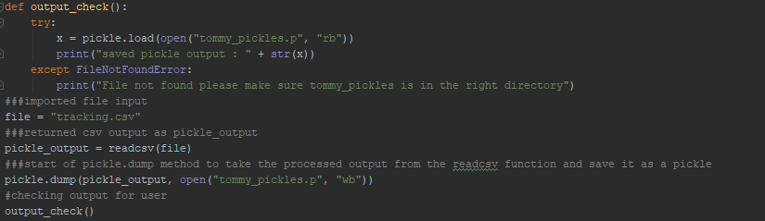

In this section we take the processed output from readcsv and save it as a pickle.

https://wiki.python.org/moin/UsingPickle

https://pythonprogramming.net/python-pickle-module-save-objects-serialization/

Conclusion – The goal of this assignment was to create a function that handled common error types, process it and then save the processed data in a pickle. By parsing the csv and saving we are able to process a dynamic csv and then save it as an expected pickle file tommy_pickles.p

Input

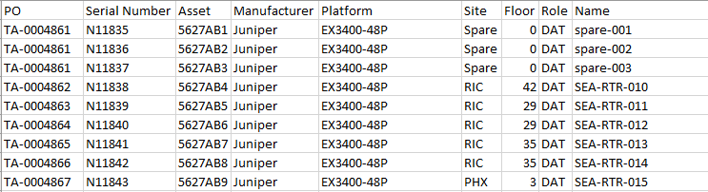

Output



Saved file

